**Reservation System**

Anish Man Shrestha

[anish.shrestha237@gmail.com](mailto:anish.shrestha237@gmail.com)

**GitHub Link:** <https://github.com/Anish-Shrestha/Reservation-System>

**To Run Project**

* Download project form above github link.
* Build the project using visual studio.
* Restore the database. (project done in code first entity framework, the tables are automatically generated even if there are no tables in newly created database)
* Change the connection string accordingly in **web.config** file.
* Exceptions are logged in log file in location “C:\ReservationSystem_Logs\Logs.txt" which is also configurable in **web.config** file.
* Run the project. (**ReservationSystem.Web** is start up project)

**Environment**

Visual Studio Community 2015, SQL Server 2012

**Project Architecture**

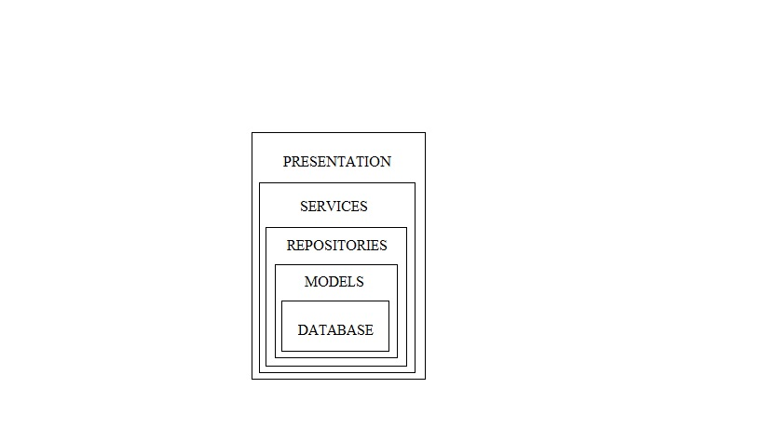

1. Above figure is the architecture of the project, it created highly loosely coupled ASP.NET Solution, where **Data Access, Business and Presentation layers** are defined in separate places.
2. This project is developed using **Entity Framework Code First development**, **Generic Repository Pattern**, Dependency Injection using **Ninject** and **Automapper** for binding view model with the domain model and vice versa.
3. The logging of the error, info is done using **Log4Net**.
4. In the **Model** section there is all of our domain objects. Entity Framework will count on them in order to build the database.
5. The entire code first configuration is in specific Configuration class.
6. The **Service** layer provides business related services to the presentation layer.
7. There are two types of validation for Search-site form, **client side and server side validation**.
8. The libraries used in front-end part are

* **Bootstrap** – It is a responsive front-end framework used for layout design of view page and for various UI components.
* **TypeheadJs** – It is used for autocomplete of location using API provided (https://api.teleport.org/api/cities/?search=%QUERY).
* **Bootstrap-datepicker** – It is used for date-picker at Check-in and Check-out textbox.
* **ValidationJs** – It is used for client side validation of the search-site form.

As per requirement, **ASP.NET** and **SQL Server** were used on the backend, to use **ASP.NET MVC** we can just replace **ReservationSystem.Web** project. Other project in this architecture like **ReservationSystem.Data, ReservationSystem.Model, ReservationSystem.Service** remains the same.

**Database Tables**

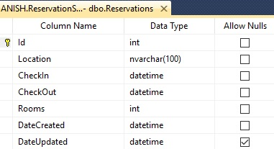 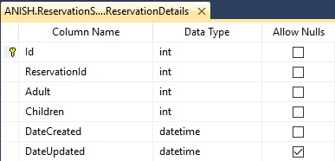

1. **Reservations**

It stores the information like Location, Check-in date, Check-out date and Number of rooms. Detail information of room is stored in **RerservationDetails** table.

1. **ReservationDetails**

It stores the information of number of adults, and children in the particular room. It contains the column **ReservationId** which is responsible for binding Reservations table with the **ReservationDetails** table.

Reservations table and **ReservationDetails** table have one to many relations. For example, reservation with 5 rooms will have 1 record in Reservation table, 5 different records in **ReservationDetails** table.

**Future Enhancement**

* Unit testing
* Integrating Unit of Work, Transactional Scope.
* Using DTO models in service layer which will segregate the domain model with the view model.

**Screen Shots**

1. **Validation**

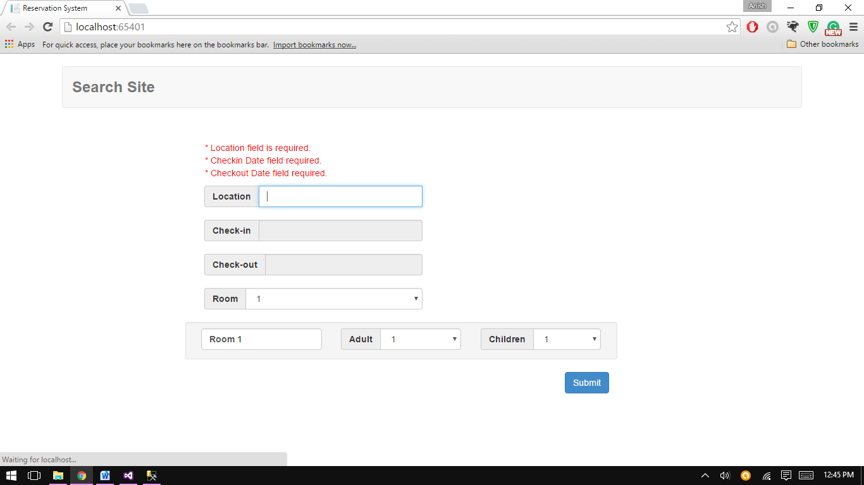

1. **Autocomplete in location**

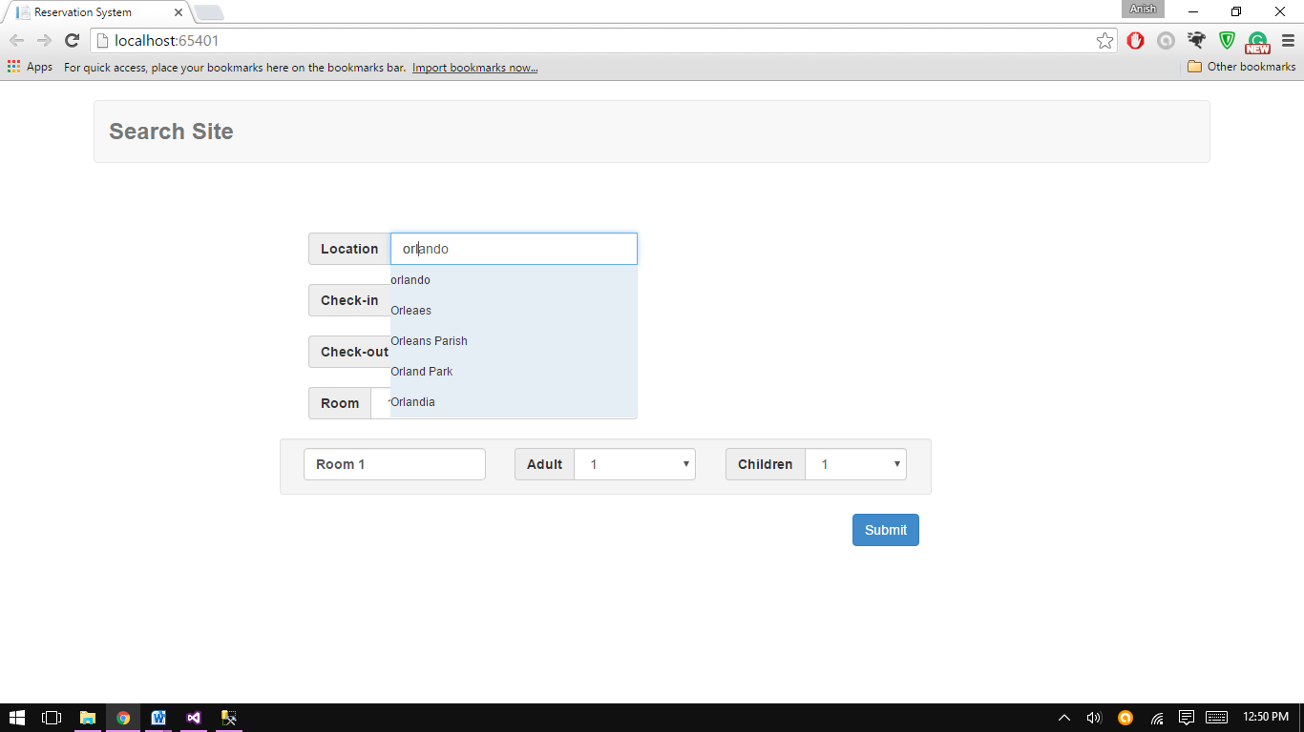

1. **Bootstrap – datepicker**

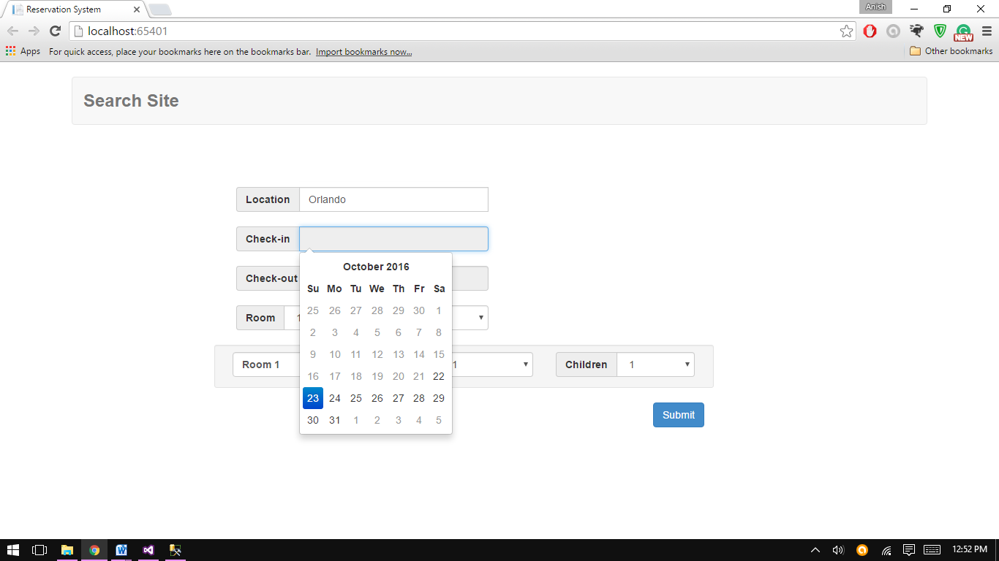

1. **Room detail list depending upon room dropdown**

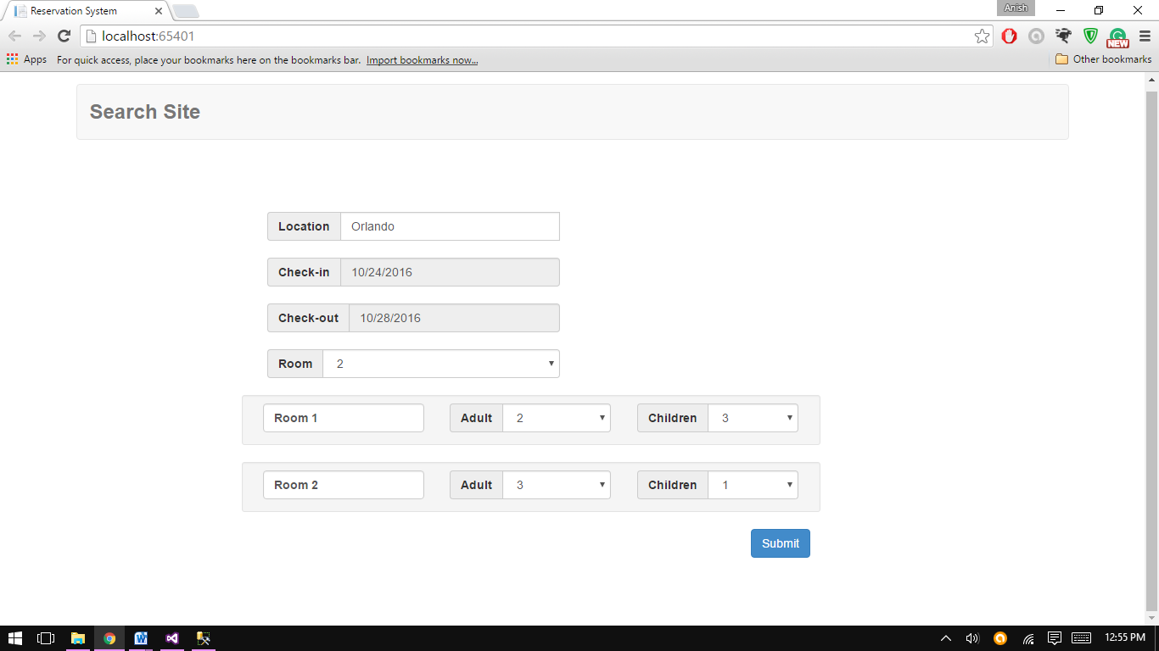

**____________________________________________________________**

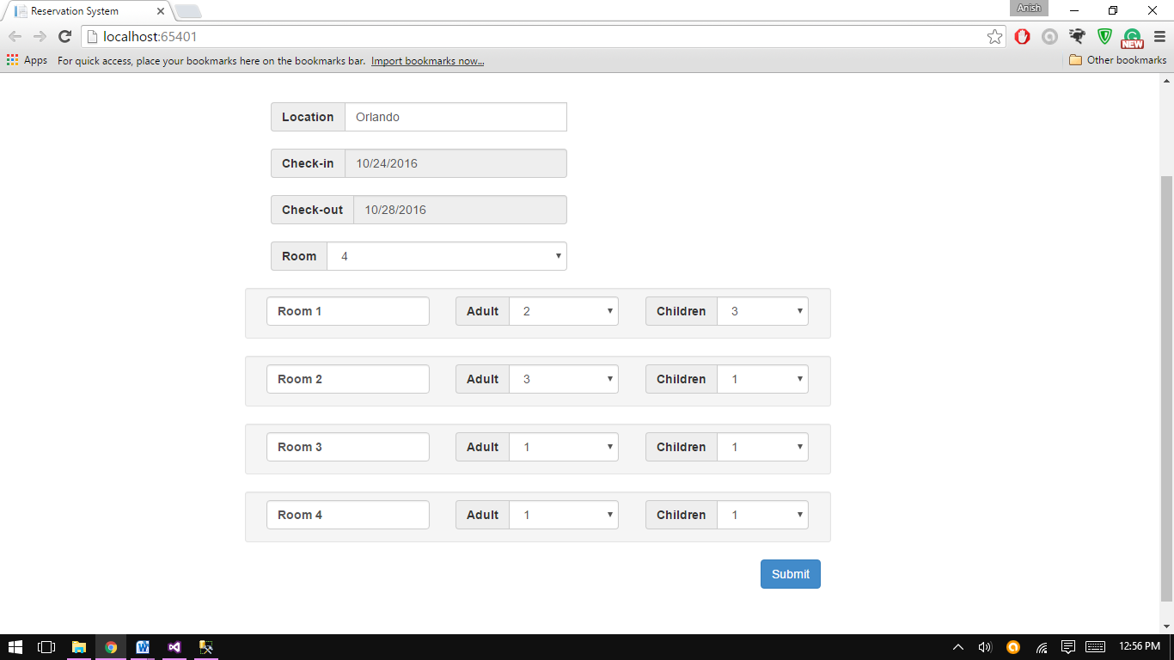

1. **Other validations**

* Check-in date must be less than check-out date

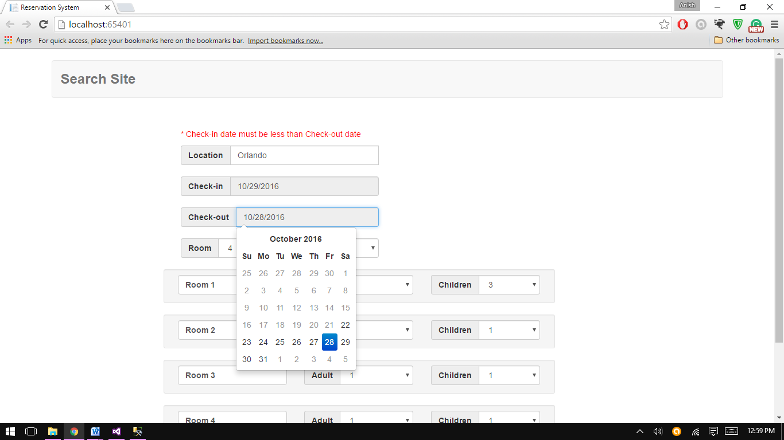

* Value selected in location is also validated using the same API.

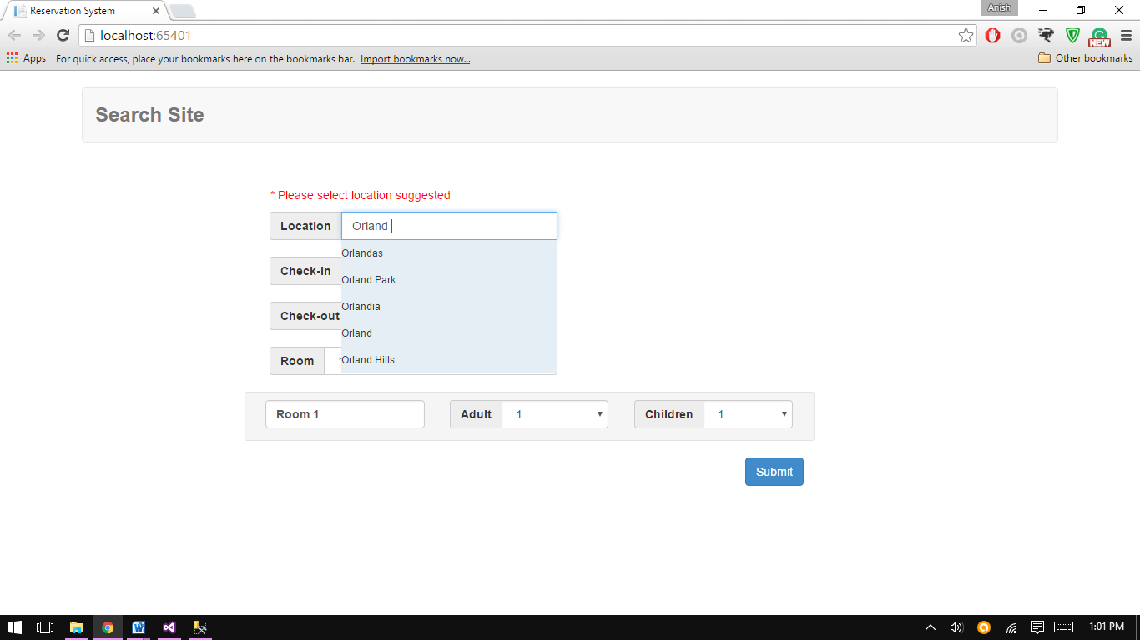

* Check-in date should not be less than today’s date.

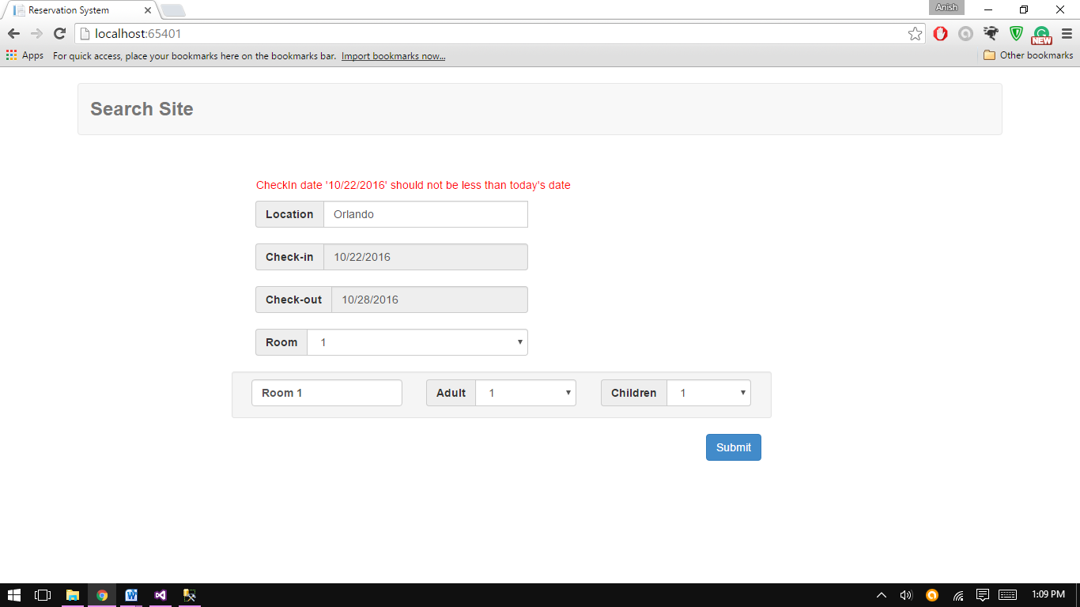

1. **Success**

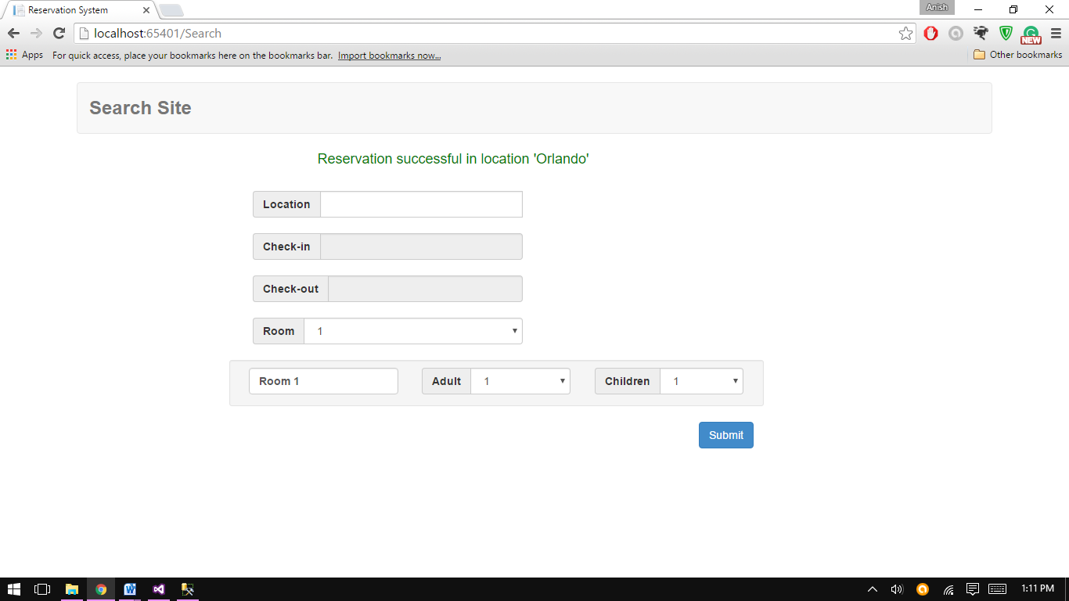

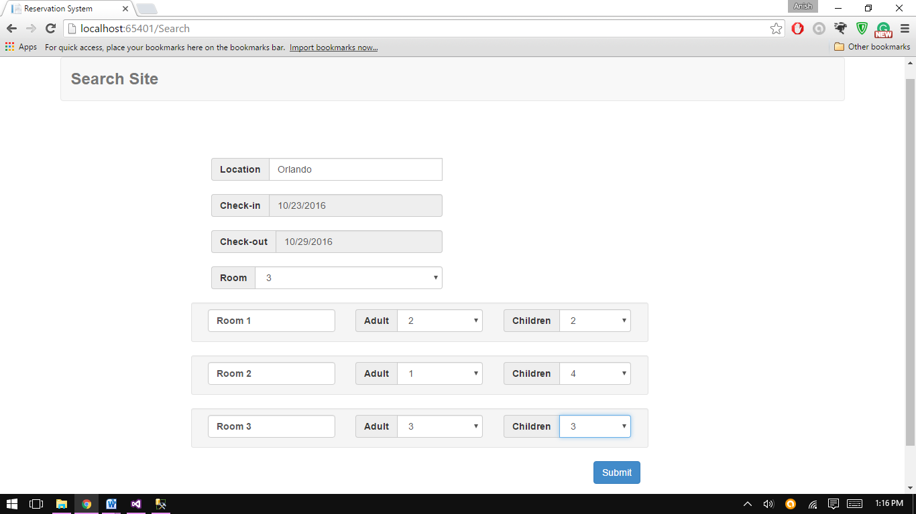

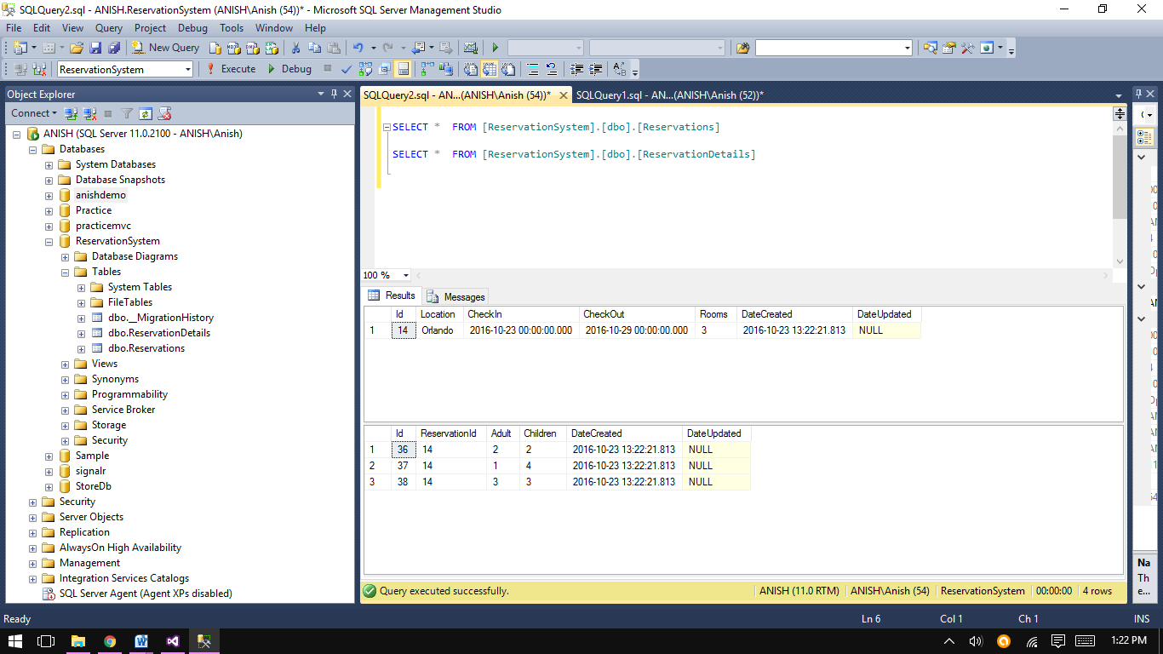

**Thanking you.**